ECF Newsletter
September 2021 - Year 1 – Weeks 1 to 4

For Early Career Teachers &Mentors enrolled on Generate Teaching Hub’s Early Career Framework.

The Early Career Framework (ECF) is a new two-year fully funded programme of support to teachers new to the profession (now known as Early Career Teachers, or ECTs); it is a statutory element of a new teacher’s induction.

The programme provides a structured system of support to complement your weekly ECT - Mentor meetings. Generate Teaching Hub is working with the national provider Teach First to provide this Department for Education (DfE) approved ‘Full Induction Programme’.

Over the first year the training for both ECTs and Mentors follows these themes:
Module 1: How can you create a powerful learning environment? | Autumn 1
Module 2: How do pupils learn? | Autumn 2
Module 3: What makes classroom practice effective? | Spring 1
Module 4: How can you use assessment and feedback to greatest effect? | Spring 2
Module 5: How can you support all pupils to succeed? | Summer 1
Module 6: How can you plan a coherent curriculum? | Summer 3

Over weeks 1 to 4, the training seminars will be led by local facilitators in covering the following topics:

ECTs |  | Mentors
- Introducing the ECF |  | - Introducing the ECF
- Developing your expertise |  | - Moving from novice to expert
- Introduction to instructional coaching |  | - Instructional coaching & deliberate practice
- Using praise and consequences effectively |  | - Improving Instruction
- Managing your wellbeing |  | - Mentoring to develop string relationships

Consult your bespoke timetable for the dates and times of your sessions.

Top tip – When attending your training sessions bring a laptop in addition to your notetaking equipment; that way you can access the presentation and extra resources in real time on Brightspace!

Contact your local lead for questions and assistance regarding the training programme
Halton | Warrington | Wigan
hsimms@wpat.uk | J.Hodgson@bridgewaterhigh.com | ECF@golbornehigh.wigan.sch.uk

Weekly Discussions

The Mentor Handbook contains weekly templates to aid your discussions with ECTs if / when appropriate. Listed below are some examples of weekly questions. Mentors can consult their handbook for more information as you tailor your contact to the ECT’s needs.

Week 1 | Introductions |  | Week 2 | Effective Entry & Settling Routines
Contact this week could focus on establishing ways of working together. |  |  | Engagement this week could involve a drop-in observation and feedback.
- Is the ECT secure in their understanding of planning responsibilities?  - Does the ECT have any questions around the behaviour or assessment policies?  - Review the sequence for year one and discuss how this can fit into your timetables. |  |  | - Why are routines so critical to classrooms? How do they support teachers to create a predictable and secure environment?  - What makes routines effective?  - Which routines do you feel are the highest leverage to your practice? Why?
Week 3 | Precise Praise & Acknowledgement |  | Week 4 | Positive & Least Intrusive Behaviour Man’t Strategies
Engagement this week could involve a drop-in observation and feedback. |  |  | Engagement this week could involve a drop-in observation and feedback.
- Why is praise so important in the classroom and what makes it effective?  - What is the difference between acknowledgement and praise?  - What strategies could you use to share pupils’ successes with their parents? |  |  | - Why is it important to manage behaviour in a positive and least invasive way?  - What should you do if you are feeling very agitated by a pupil in your class?

Have you logged into Brightspace?
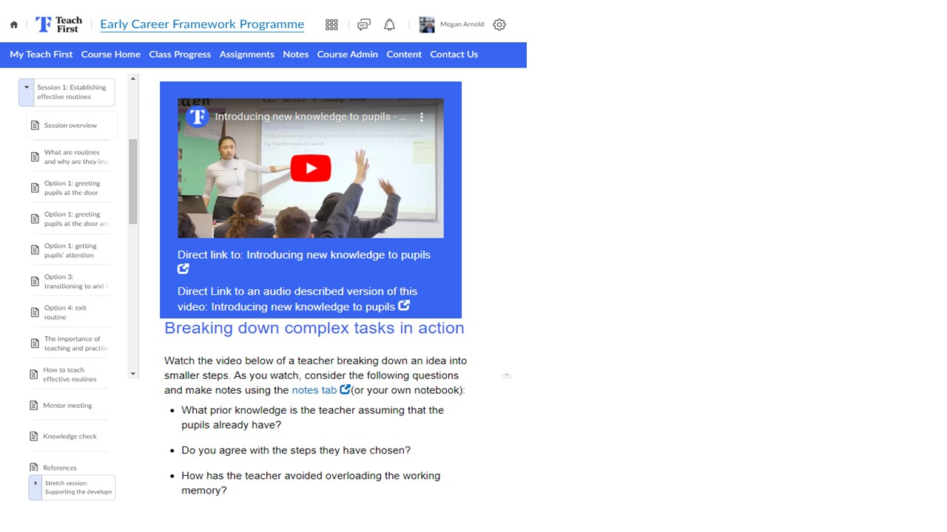 | Teach First has provided every ECT and Mentor with a unique log in for their online learning platform called Brightspace. Here you will find all materials for each seminar, resources to assist with your self-directed learning and videos, templates and exemplars to complement the programme.
 | **ECTs** Use Brightspace weekly to consolidate your learning and to demonstrate your steady progress – this will give you evidence to utilise in your termly Induction reports.

