Booking Course Places with NWLP on Bookwhen website

If you wish to book on any training places at our events we have a new web-based booking system launching on 1st June 2022. This will enable staff to book their own places or for your school CPD coordinator to book on behalf of all staff. We will be running tests on certain CPD events for Summer 2022 using this system.

Please visit www.bookwhen.com/nwlp

Below is a test version of the homepage and all courses will appear on the left side of the screen in a calendar and when a specific course is selected the information will then appear on the right:-

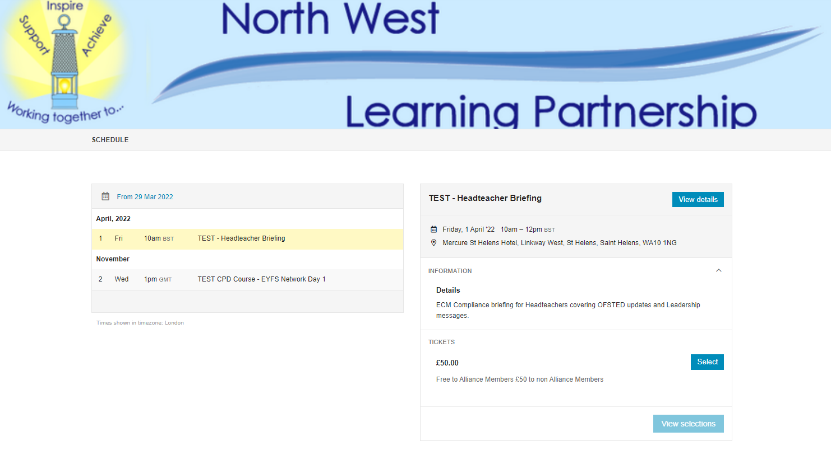

Once a course has been selected it will appear in the basket at the top right of the screen. To complete the booking you will need the following information to hand in order to complete the screen below:-
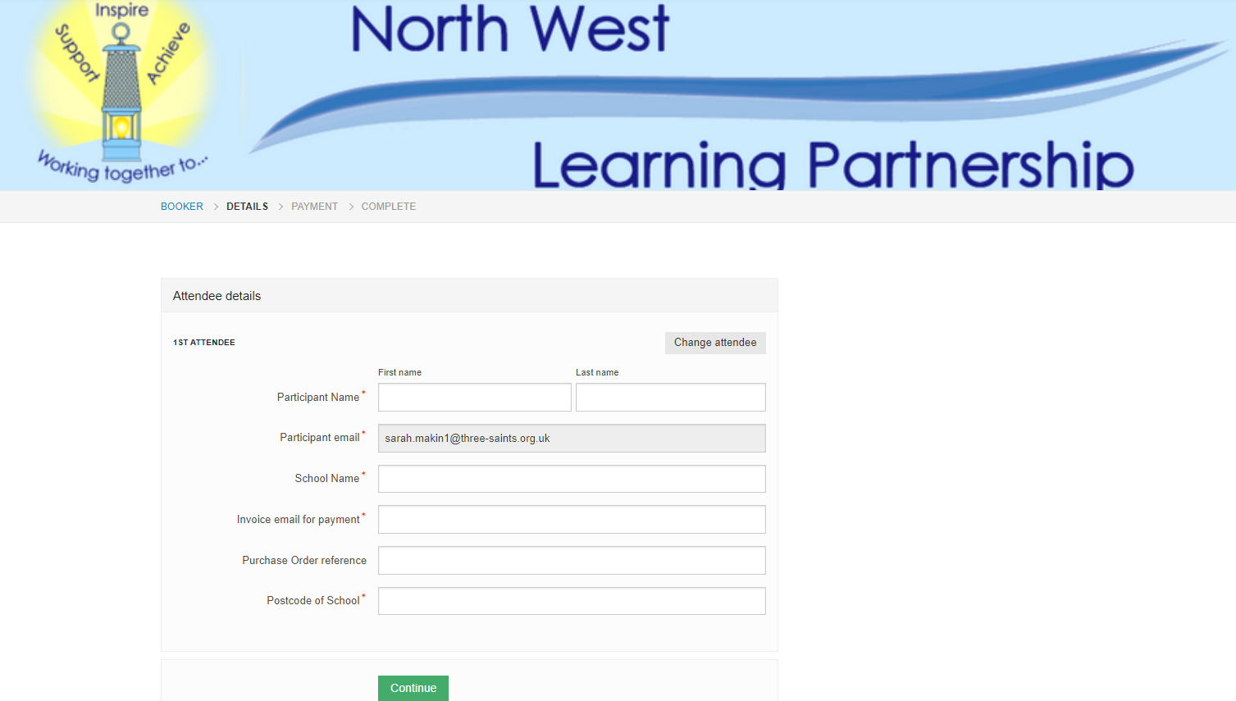
Once this has been completed the booking system will record and then send confirmation emails to the appropriate personnel.
We are using some events as a pilot for schools/delegates to book their places to ensure smooth running and also to iron out any potential teething problems anyone has.

If you have any problems using the booking system please email Paula Foster and Sarah Makin who will help – paula.foster@three-saints.org.uk and sarah.makin@three-saints.org.uk

